## Homework 5_2

#### **Problem 1:**

x = -2:0.1:2; % x values from -2 to 2 with a step of 0.1

y = x.^4;

y_inv = x.^(1/4);

figure; % Create the plot

% Create subplots

subplot(2, 1, 1);

plot(x, y, 'b', 'LineWidth', 2);

xlabel('x');

ylabel('y');

title('Original Function: y = x^4');

grid on;

subplot(2, 1, 2);

plot(x, y_inv, 'r', 'LineWidth', 2);

xlabel('x');

ylabel('y');

title('Inverse Function: y = x\^(1/4)');

grid on;

% Title

sgtitle('Plots of Function and Its Inverse');

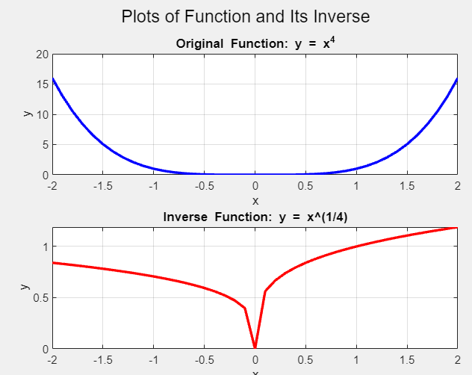

#### **Problem 2:**

x = -3:0.1:3; % x values from -3 to 3 with a step of 0.1

y = 5 * x + 2;

figure; % Create the plot

plot(x, y, 'b-', 'LineWidth', 2);

xlabel('x');

ylabel('y');

title('Function: y = 5x + 2');

grid on; % Add grid

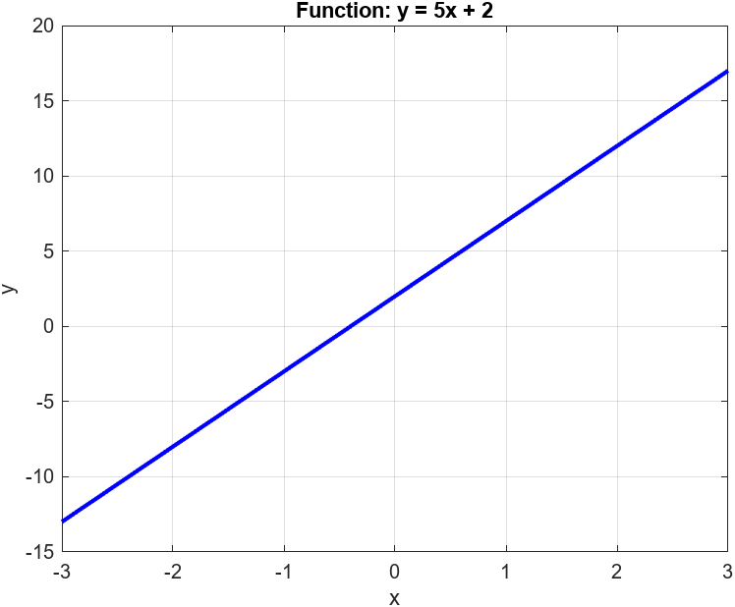

#### **Problem 3:**

x = -3:0.1:3; % x values from -3 to 3 with a step of 0.1

y = -x -1;

figure; % Create the plot

plot(x, y, 'b-', 'LineWidth', 2);

xlabel('x');

ylabel('y');

title('Function: y = 5x + 2');

grid on; % Add grid

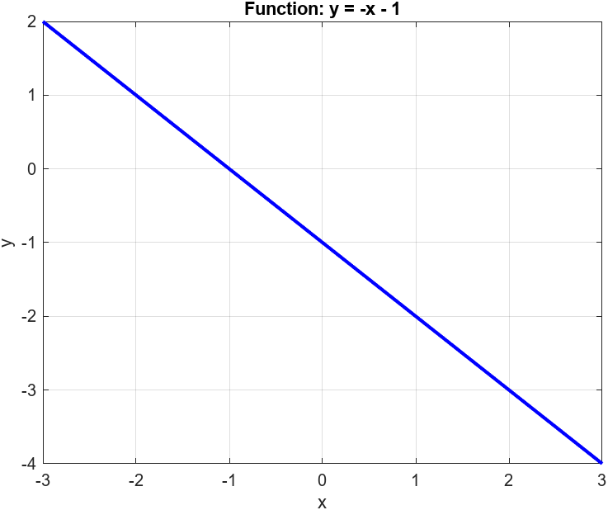

#### **Problem 4:**

x = -3:0.1:3; % x values from -3 to 3 with a step of 0.1

y = x.^3 + 2 * x.^2 + 2 * x + 1;

figure; % Create the plot

plot(x, y, 'b-', 'LineWidth', 2);

xlabel('x');

ylabel('y');

title('Function: y = x^3 +2x^2 +2x +1');

grid on; % Add grid

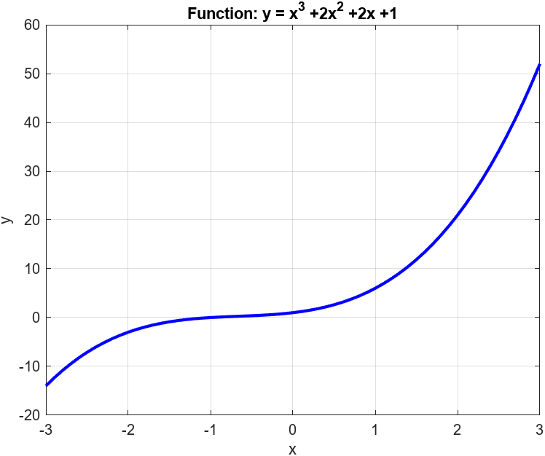

#### **Problem 5:**

x = -3:0.1:2; % x values from -3 to 2 with a step of 0.1

y = 2 * x.^5 + 6.4721 * x.^4 + 10.4721 * x.^3 + 10.4721 * x.^2 + 6.4721 * x + 2;

figure; % Create the plot

plot(x, y, 'b-', 'LineWidth', 2);

xlabel('x');

ylabel('y');

title('Function: y = 2x^5 + 6.4721x^4 + 10.4721x^3 + 10.4721x^2 + 6.4721x +2');

grid on; % Add grid

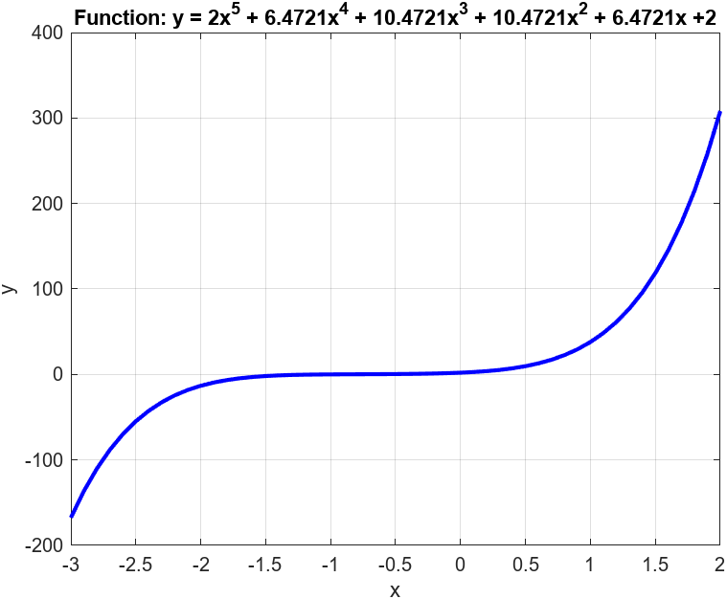

#### **Problem 6:**

t = 0:0.01:(5 * 0.2); % time values from 0 to 1 seconds with a step of 0.01

a = 0.04 * exp(-t/0.2);

figure; % Create the plot

plot(t, a, 'b-', 'LineWidth', 2);

xlabel('Time (s)');

ylabel('Current (a)');

title('Function: i(t) = 0.04e^(-t/0.2)');

grid on; % Add grid

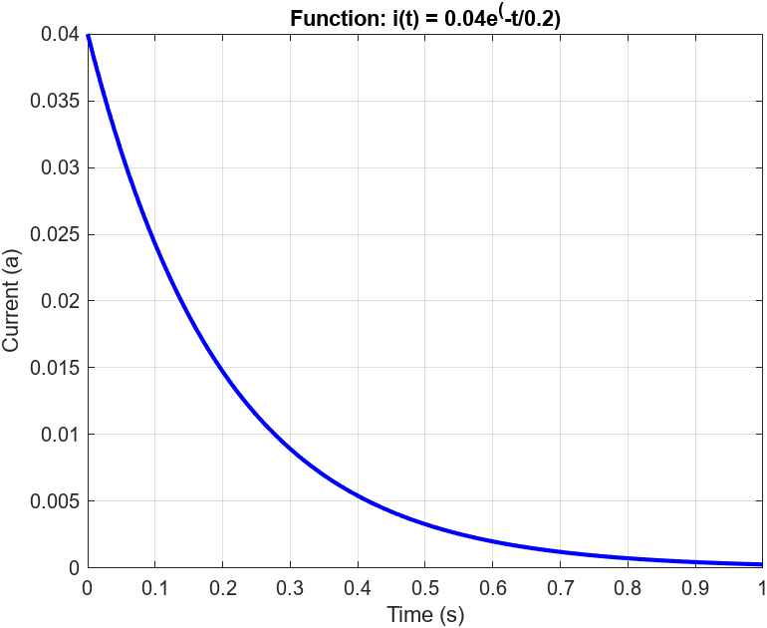

#### **Problem 7:**

t = 0:1:(5 * 20); % time values from 0 to 100 seconds with a step of 1

T = -10 + 80 * exp(-t / 20);

figure; % Create the plot

plot(t, T, 'b-', 'LineWidth', 2);

xlabel('Time (s)');

ylabel('Temperature (F)');

title('Function: T(t) = -10 + 80*e\^(-t/20)');

grid on; % Add grid

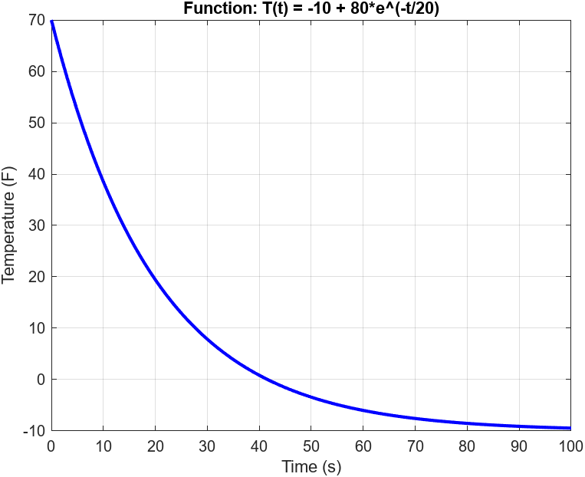

#### **Problem 8:**

A = logspace(log10(0.1), log10(10), 100); % Generate 100 points between 0.1 and 10

AdB = 20 * log10(A);

% Create a semi-log plot

semilogx(A, AdB, 'b', 'LineWidth', 2);

xlabel('A (Voltage Ratio)');

ylabel('AdB (Decibel Ratio)');

title('Conversion Curve: A vs AdB');

grid on;

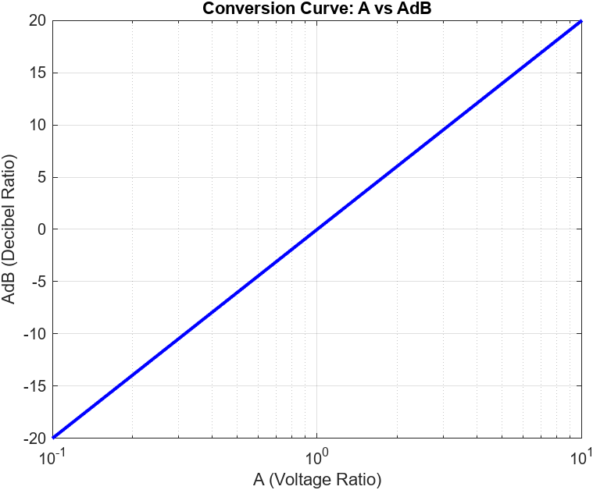

#### **Problem 9:**

cycle = (2*pi)/5; % Calculate the period of the function

t = linspace(0, (3*cycle), 1000);

y = 15 * cos(5*t + ((60/180)*pi));

% Create the plot

plot(t, y, 'b', 'LineWidth', 2);

xlabel('Time');

ylabel('y');

title('Plot of y = Acos(wt + a)');

grid on;

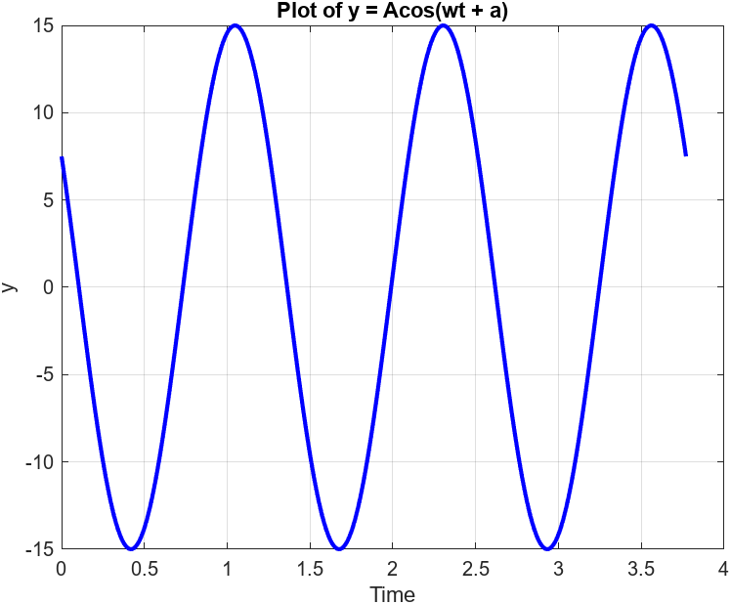

#### **Problem 10:**

t = linspace(5, 15, 1000);

x = 10 * cos(2 * t);

y = 10 * sin(2 * t);

z = 10 * t;

% Create a 3D plot

figure;

plot3(x, y, z, 'b', 'LineWidth', 2);

xlabel('X');

ylabel('Y');

zlabel('Z');

title('3D Plot: x = 10 * cos(2t), y = 10 * sin(2t), z = 10t');

grid on;

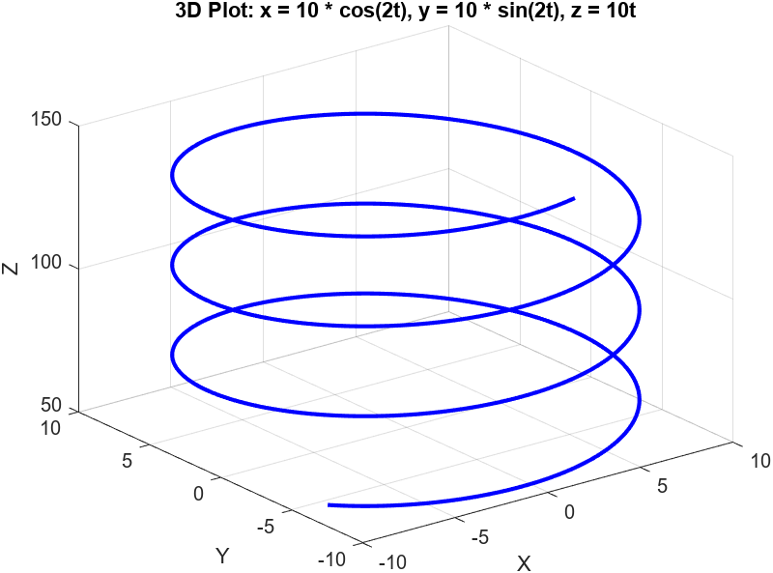

#### **Problem 11:**

theta = linspace(0, 2*pi, 1000);

g = sin(theta).^8;

% Create a polar plot

polarplot(theta, g, 'b', 'LineWidth', 2);

title('Polar Plot of g(\theta) = sin^8(\theta)');

